keke

# KENDRIYA VIDYALAYA BHIMTAL

# WINTER BREAK HW (2021-22)

# CLASS – IX SUB- MATHS

# Level-1

1. Find the total surface area of a hemisphere of radius 10 cm. (Use π = 3.14)

#### OR

Find the height of cone, if its slant height is 34 cm and base diameter is 32 cm.

1. In a bag, there are 100 bulbs out of which 30 are defective ones. A bulb is taken out of the bag at random. Find the probability of the selected bulb to be a good one.
2. If its perimeter of an equilateral triangle is 180 cm, what will be its area?
3. 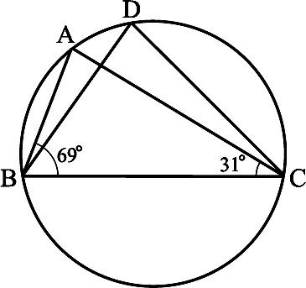In the below figure,  ABC = 69°,  ACB = 31°, find  BDC.

# Level -2

1. A river 3 m deep and 40 m wide is flowing at the rate of 2 km per hour. How much water will fall into the sea in a minute?
2. Find the value of x3 + y3 + 15xy – 125 if x + y = 5.

#### OR

Find the remainder when 4x3 – 3x2 + 4x – 2 is divided by (i) x – 1 (ii) x – 2

1. The following observations have been arranged in ascending order. If the median of the data is 63, find the value of x.

29, 32, 48, 50, x, x + 2, 72, 78, 84, 95

1. The angles of quadrilateral are in the ratio 3 : 5 : 9 : 13. Find all the angles of the quadrilateral.
2. Find the area of a triangle two sides of which are 18cm and 10cm and the perimeter is 42cm.

#### OR

Calculate the area of trapezium as shown in the figure:

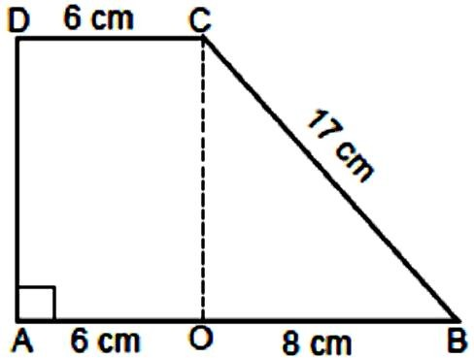

1. 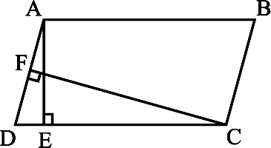In the below figure, ABCD is a parallelogram, AE  DC and CF  AD. If AB = 16 cm, AE = 8 cm and CF = 10 cm, find AD.

**Level -3**

1. In the below figure, ABCD is a quadrilateral and BE || AC and also BE meets DC produced at

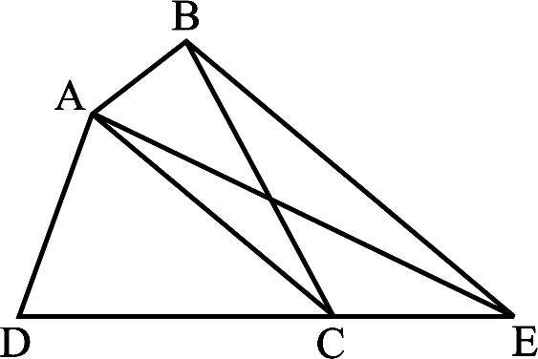E. Show that area of Δ ADE is equal to the area of the quadrilateral ABCD.

#### OR

Show that a median of a triangle divides it into two triangles of equal areas.

**14.** Factorise *x*3 – 23*x*2 + 142*x* – 120.

1. A die is rolled 300 times and following outcomes are recorded:

|  |  |  |  |  |  |  |
| --- | --- | --- | --- | --- | --- | --- |
| **Outcome** | 1 | 2 | 3 | 4 | 5 | 6 |
| **Frequency** | 42 | 60 | 55 | 53 | 60 | 30 |

Find the probability of getting a number (i) more than 4 (ii) less than 3

1. 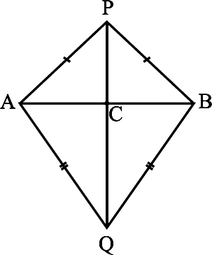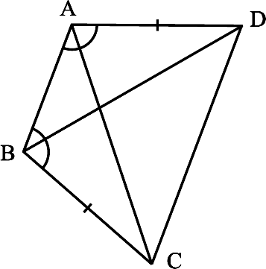AB is a line-segment. P and Q are points on opposite sides of AB such that each of them is equidistant from the points A and B (see below left figure). Show that the line PQ is the perpendicular bisector of AB.

#### OR

ABCD is a quadrilateral in which AD = BC and  DAB =  CBA (see the above right sided

figure). Prove that (i) Δ ABD  Δ BAC (ii) BD = AC (iii)  ABD =  BAC.

1. A chord of a circle is equal to the radius of the circle. Find the angle subtended by the chord at a point on the minor arc and also at a point on the major arc



3  2

3  2

1. A dome of a building is in the form of a hemisphere. From inside, it was white-washed at the cost of Rs 498.96. If the cost of white-washing is Rs 2.00 per square metre, find the (i) inside surface area of the dome, (ii) volume of the air inside the dome.

#### OR

Monica has a piece of canvas whose area is 551 m2. She uses it to have a conical tent made, with a base radius of 7 m. Assuming that all the stitching margins and the wastage incurred while cutting, amounts to approximately 1 m2, find the volume of the tent that can be made with it.

1. Show that if the diagonals of a quadrilateral bisect each other at right angles, then it is a rhombus.

#### OR

Prove that “The line-segment joining the mid-points of any two sides of a triangle is parallel to the third side and is half of it

1. The following table gives the life times of 400 neon lamps:

|  |  |
| --- | --- |
| **Life time (in hours)** | **Number of Lamps** |
| 300 – 400 | 14 |
| 400 – 500 | 56 |
| 500 – 600 | 60 |
| 600 – 700 | 86 |
| 700 – 800 | 74 |
| 800 – 900 | 62 |
| 900 – 1000 | 48 |

* 1. Represent the given information with the help of a histogram.
  2. How many lamps have a life time of more than 700 hours?

1. If x3 + ax2 + bx + 6 has (x – 2) as a factor and leaves a remainder 3 when divided by (x – 3), find the values of a and b.

#### OR

Without actual division, prove that 2x4 – 6x3 +3x2 +3x – 2 is exactly divisible by x2 – 3x + 2.

